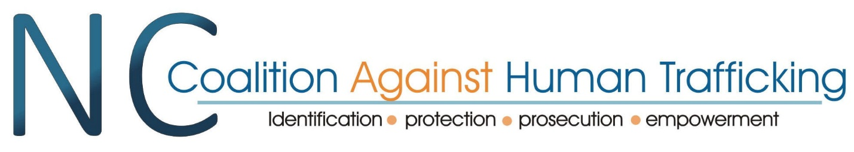

**Membership Meeting Agenda**

October 10, 2024

Welcome

Introduction of Board Members and Officers

* In person – Pam, Cindy, Sarah Michael
* Virtual – Dawn, Nikki, Dean

Introduction of Members

Present Virtually

Kara Griffin

Jenn Hagna

Nancy Hagen

Courtney Dunkerton

Niki Miller

Deidre Michell

Shirley Rutledge

Lance Lamonte

Richard (Rick) Blaylock

Brianna Raccchini

Anne Friesen

Shirley Rutledge

Members in person, Sign-in sheet:

Mike Thompson

Kendra

Kiricka

Report from the Chair – Pam touching base with where we are now. A revisioning and rebuilding phase to the mission, vision, and priorities for helping move forward Human trafficking work. A consultant was used from Mission Triangle to help guide the board in a retreat. We spoke about the general ideas of board governance as well as the goals our board wants to have. An introduction into our mission and vision statement. A big focus here is on member connections and collaboration because it is the best way to become educated and source resources for the work.

* Community Engagement Team (to connect each member’s personal community to other larger places), Fundraising team (a staff member is a big goal here), and the communications (aid with Newsletters, social media, and our website)
* Questions of survivor input and voice. Our history includes the survivor network which is now its own nonprofit entity that we seek to further collaborate with. Continue the free membership extensions to any person who self discloses as a survivor.

NCCAHT representative to the Human Trafficking Commission – Angelica Wind has been our representative in the past and is stepping away from this role. In her place is NCCAHT board member Dawn Ferrier! A meeting is coming soon so keep an eye out, December 12, 2024 General Commission Meeting 10:00 a.m. – 12:00 p.m. N.C. Judicial Center, Dogwood and Magnolia Rooms, Raleigh Via Webex <https://nccourts.webex.com/nccourts/j.php?MTID=m1187bb9c155e09adb49e574d8afe699e>

Board Elections Update – We have openings! Our bylaws have a set 13-member board, and we are currently at 9. Expect an email with information about nominations and voting information. Remember to have nominees who are members with up-to-date dues.

Speaker Ashley Tauscher – power point sent to Board

Overview of the commission – 2012 creation as temporary, 2013 became permanent – 2021 was granted operating funds.

Seven/six charges – with one being resolved by legislation to have those persons accused of sex trafficking be registered to offender lists

Members – governor, senate speaker, and branch seats – with other accompanying committees and seats (held for 2 years per time and can hold it repeatedly)

Court management position funded by VAWA – training, contract with other nonprofits/gov orgs, develop materials – most recently DPI, a module on sex trafficking, technical assistance, and case consulting with entities, state-wide conferences, and a virtual resource directory/library

Regional response teams within the HTC – where are they now? We have an interest as NCCAHT to see which teams are still operational and may need support.

Mandated Reporting toolkit on the HTC

**Discussion Topic: Housing for Survivors**

Brought up by Lance Lemmonds, a member with Forever Free, who’s org finds short/medium term housing. What are barriers to finding this? And additionally, what happens when you have funding how to do find places that actually have space? Hotels have been the solution used currently, but the fix isn’t perfect.

Member Parker chimed in, she belongs to an organization in a similar situation who does crisis response but not housing, so they source that from other places. She also is seeing issues with survivor access to mental health meds. Is there any providers who may have run into this or can help with it?

How does longer term residential programs fail these survivors? A focus on program completion before shelter services are offered. How do their protocols stand in the way of specific human trafficking?

Chime in from organizational member Edith with Justice matters, typically after the incident for the client while seeking services like T-visas, etc. there are often issues with getting housing services as this org serves survivors who are undocumented and find themselves behind on their rent. A prevention issue was noted with maintaining what housing is present. Lance offered some funds that he may have to help with this issue. He typically serves specific counties but can occasionally help with immediate trauma care.

NC Housing Finance Agency (Potential resource? More info in follow up email) – 10 million was given by legislation in 2023, and have earlier tried to gather information on how to use these funds for HT survivors, 501 C3 funding – just brick and mortar

Announcements from those in attendance -

* Kara – Truckers against trafficking is at 2pm today! A publication about Hurricane response for HT survivors
* Niki Miller – NC Demand reduction task force, HT x Tech webinar series
* Kiricka – Oct 30th, webinar to address to best serve African American Survivors

**Membership meetings for 2025**

Jan 24 Membership 11-12:30

April 10 Membership 11-12:30

July 10 Membership 11-12:30

Oct 9 Membership 11-12:30

Adjourn

**Mission Statement**

We foster connection and collaboration

within the anti-human trafficking community.

**Vision Statement**

A united effort to end

Human Trafficking in North Carolina